Sprint 1 - Endurance Design Document

November 8, 2021

Table of Contents

1. Executive Summary 3

1.1 Project Overview 3

1.2 Purpose and Scope of this Specification 3

2. Product/Service Description 3

2.1 Product Context 3

2.2 User Characteristics 3

2.3 Assumptions 3

2.4 Constraints 3

2.5 Dependencies 4

3. Requirements 4

3.1 Functional Requirements 5

3.2 Security 5

3.2.1 Protection 5

3.2.2 Authorization and Authentication 6

3.3 Portability 6

4. Requirements Confirmation/Stakeholder sign-off 6

5. System Design 6

5.1 Algorithm 6

5.2 System Flow 6

5.3 Software 6

5.4 Hardware 6

5.5 Test Plan 7

5.6 Task List/Gantt Chart 7

5.7 Staffing Plan 7

# Executive Summary

## Project Overview

This product is one leg of a larger product testing the abilities of the Sphero SPRK+ robot using different courses / sprints. Each course is located on the floor of room HH-208. This part of the project is called the Endurance sprint. The robot will navigate the room with the goal being for it to stay on the blue lines laid out on the floor in the shape of a rectangle. A video will be taken of the robot completing the sprint. It will then be turned in to the professor alongside the block code and other requested information.

## Purpose and Scope of this Specification

In scope

This part of the project involves testing for Endurance only, as explained in section 2.1.

Out of Scope

This part of the project does not involve testing for Agility and Accuracy.

# Product/Service Description

## Product Context

This product is part of a larger project containing three different sprints- Endurance, Accuracy, and Agility. This is the first of the three products- the Endurance sprint. All three of these products will be presented through video.

## User Characteristics

Our group of three students will be using the product during testing and while taking the final video of the sprint. We have minimal experience using the robot so far, but some of us have experience with software development in general and at least one of us has used JavaScript-based block code before.

The professor will also be testing our code.

## Assumptions

We are to use an SPRK+ robot and the Sphero Edu application for development. We must use a predetermined course located inside room HH-208. The application can be used on mobile or a laptop, but we are using laptops to create the block code. We are using phones to film the robot (the program can also be run on the phone while filming).

## Constraints

The room containing the course for the Endurance sprint is not always available, therefore limiting the times at which the group can meet up and test the robot on the course. On top of this, it is difficult for our group to meet up and work in person in general due to some members having major time constraints.

Also, as the course is constrained to one room and is only available at certain times, multiple groups of people were testing their robots in the room at similar times, making it so that there was less time available for us to test ours so as not to keep others waiting for too long. (This was only an issue during the second round of testing, especially with only one group member available so the testing was slower.)

## Dependencies

Any dependencies are explained inside the requirements chart in section 3.1.

# Requirements

## Functional Requirements

| Req# | Requirement | Comments | Priority | Date Rvwd | SME Reviewed / Approved |
| --- | --- | --- | --- | --- | --- |
| ENDUR_01 | Robot will start from yellow square with blue tape |  | 1 | 10/28 | 10/28 |
| ENDUR_02 | Robot will start with green light |  | 1 | 10/28 | 10/28 |
| ENDUR_03 | Robot will speak ‘ready set go’ |  | 1 | 10/28 | 10/28 |
| ENDUR_04 | Robot will travel to each corner of rectangular course | 4 corners  Should be done in an order so that robot navigates periphery of room according to ENDUR_06 | 1 | 10/28 | 10/28 |
| ENDUR_05 | Robot will turn right at the center of each corner | Turns 90 degrees  (in block code, turning 90 degrees is indicated by adding 90 degrees to previous rotation) | 1 | 10/28 | 10/28 |
| ENDUR_06 | Robot will travel around periphery of HH208, staying on blue line | Accomplished through previous two requirements  Robot must be properly oriented in the beginning in order to accomplish this | 1 | 10/28 | 10/28 |
| ENDUR_07 | Robot will not collide with objects as it moves | Any tables and chairs in the way are moved before running program | 1 | 10/28 | 10/28 |
| ENDUR_08 | Robot will return to its starting location | Starting location is yellow square with blue tape | 1 | 10/28 | 10/28 |
| ENDUR_09 | Robot will stop with red light |  | 1 | 10/28 | 10/28 |
| ENDUR_10 | Robot will speak ‘I’m done and I need water’ |  | 1 | 10/28 | 10/28 |

## Security

### Protection

As a group, we did not feel that it was worth putting more extreme protective measures on our program. We did use a password protected account on the Sphero Edu application, however, that would protect our code. The robot itself is also secured in a case when not being used.

### Authorization and Authentication

N/A

## Portability

This system is overall not portable. The track is located in HH-208, and therefore the robot must be run in this room. The robot itself and laptop being used to run the robot can be moved around, but as the laptop uses Bluetooth to run the robot, the robot must be near the laptop in order to run.

# Requirements Confirmation/Stakeholder sign-off

|  |  |  |
| --- | --- | --- |
| Meeting Date | Attendees | Comments |
| 10/28/21 | Jarek, Anjali, James | All requirements approved |

# System Design

## Algorithm

* Start on yellow corner with blue tape
* Change light to green
* Speak “ready set go”
* Travel forward to end of blue line
* Turn 90 degrees at center of corner
* Travel forward to end of blue line
* Turn 90 degrees at center of corner
* Travel forward to end of blue line
* Turn 90 degrees at center of corner
* Travel forward to end of blue line
* Change light to red
* Speak “I’m done and I need water”

## System Flow

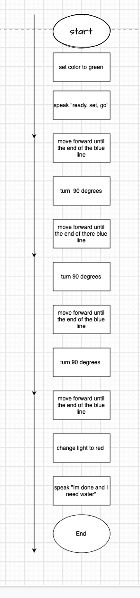

## Software

This product is programmed using the Sphero Edu application for Windows. It was run during testing and filmed using the Sphero Edu app for iPhone. This application uses block code.

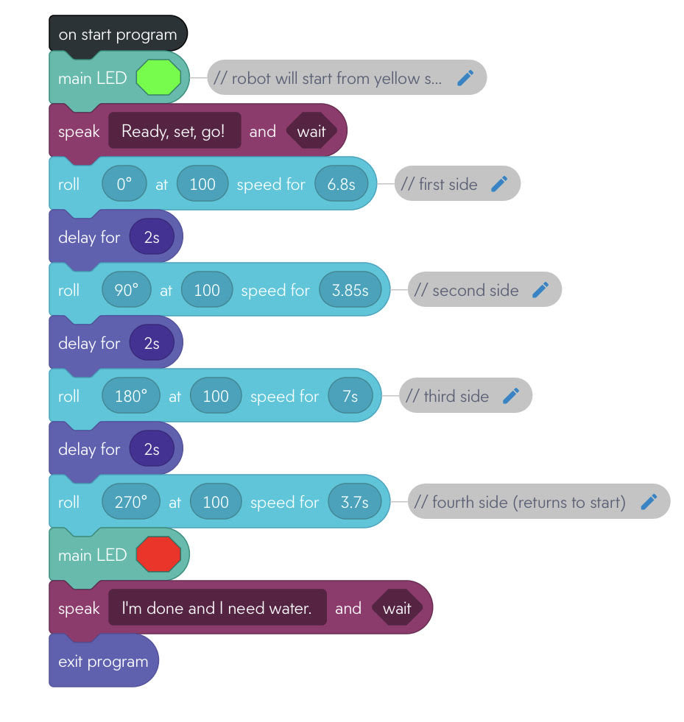

Block code for Endurance sprint – Sphero Edu app

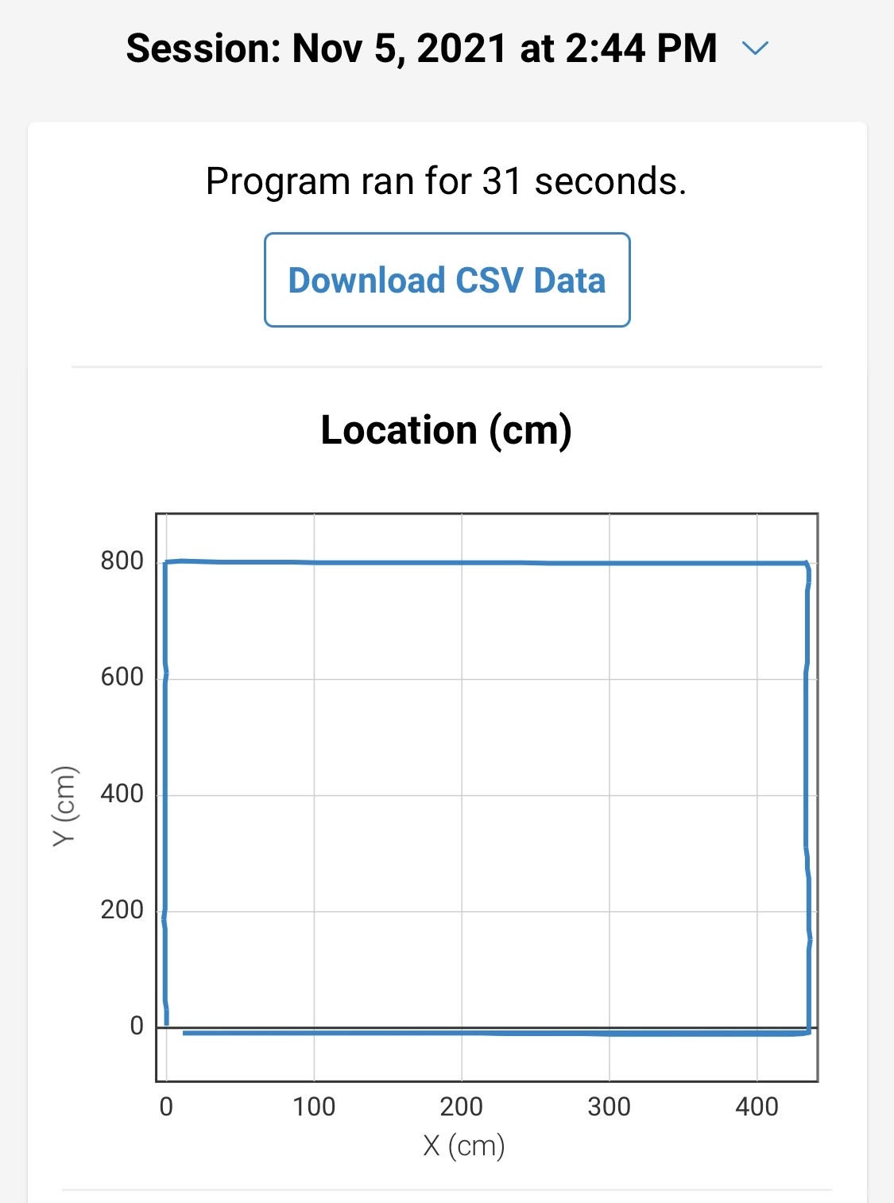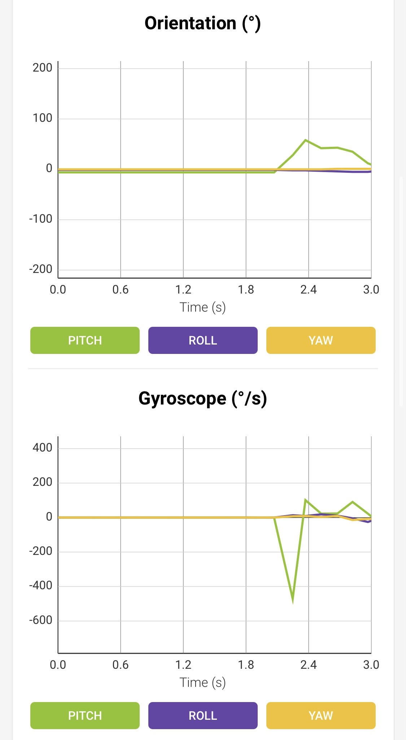

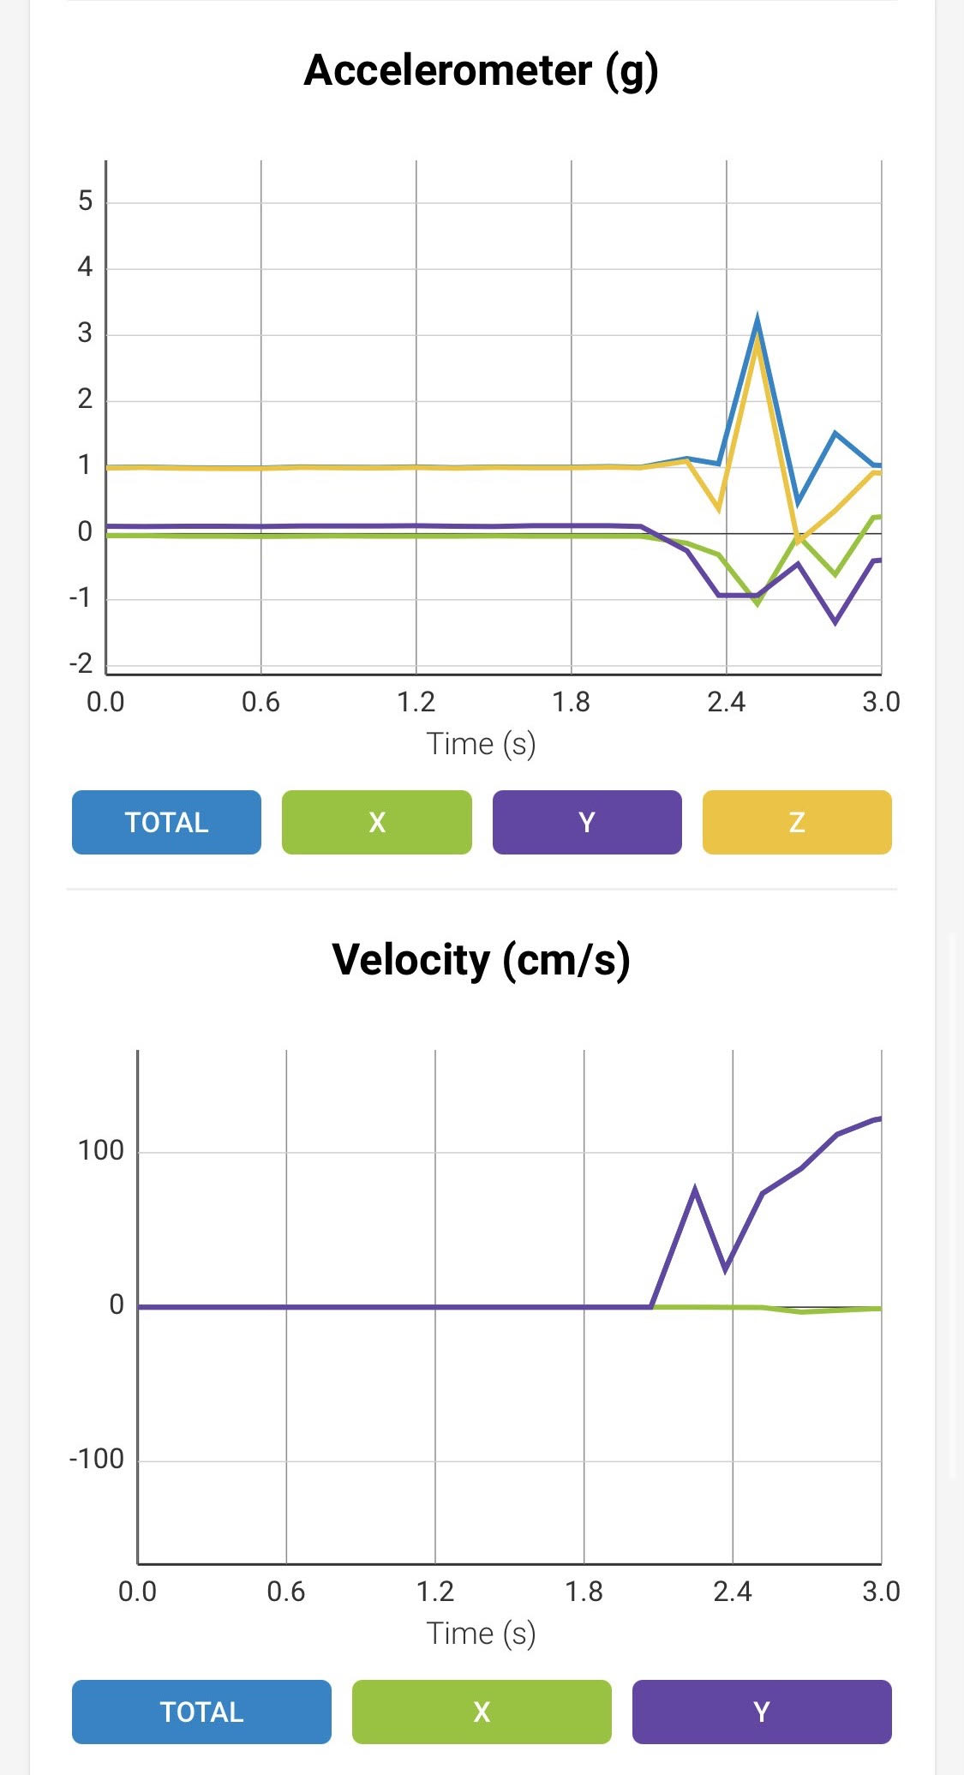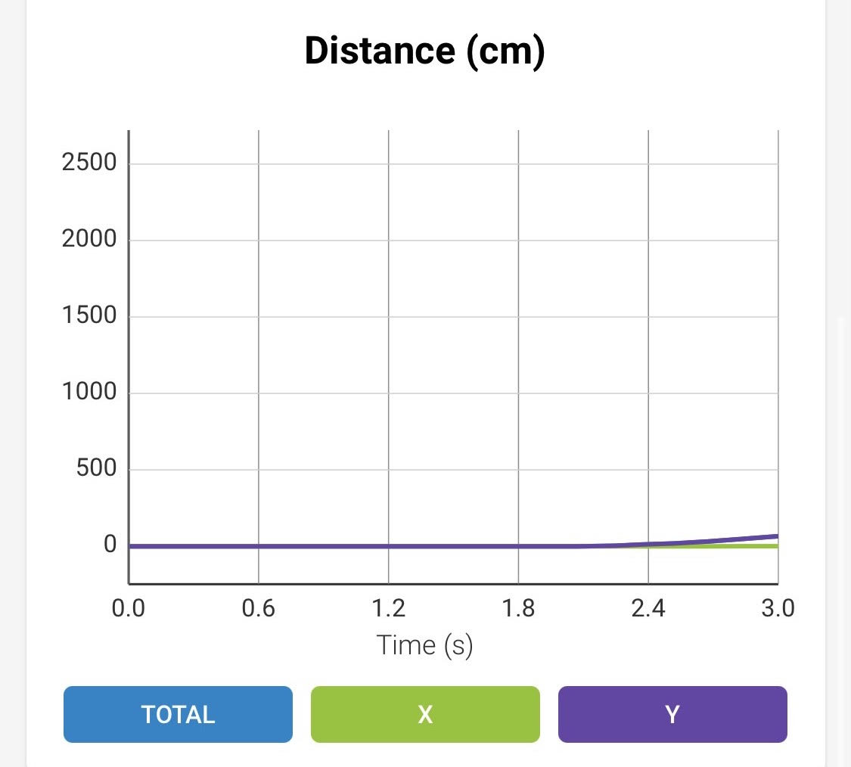

Sensor data diagrams – Sphero Edu app

## Hardware

The robot being used is the Sphero SPRK+. The block code was programmed using an HP laptop. The robot was run and filmed using an iPhone.

## Test Plan

| **Reason for Test Case** | **Test Date** | **Expected Output** | **Observed Output** | **Staff Name** | **Pass/Fail** |
| --- | --- | --- | --- | --- | --- |
| Seconds travelled for robot to navigate first side of track | 10/28 | As this was a guess, it was expected that robot would stop short of or go further than end of first side | Guess appeared correct alongside our selected robot speed- robot stopped at end of side, staying on line entire time | All | Pass |
| Robot travels on first side staying directly on blue line | 10/28 | Repeating previous test case to ensure it worked- same observed output expected | We were unable to keep robot from moving diagonally away from line- difficulty orienting it before running program | All | Fail |
| Seconds travelled for robot to navigate second side of track | 10/28 | This was done before fully fixing orientation issue, so expected output was just close estimate of how many seconds robot should travel after turning at first corner | Robot stopped close to second corner | All | Pass |
| Robot stays on first blue line and reaches the end | 10/5 | Expected that there would need to be a few tests for this in order to properly orient robot | Robot strayed slightly to the right of the blue line | Anjali | Fail |
| Robot stays on first blue line and reaches the end | 10/5 | Robot reaches end of the blue line staying on it | Robot stayed on blue line and reached the end of it | Anjali | Pass |
| Robot stays on first and second blue line | 10/5 | Robot stays on first blue line and on second blue line and reaches end of second line | Robot stopped short on second blue line | Anjali | Fail |
| Robot stays on first and second blue line and reaches end of second line | 10/5 | Seconds was increased for the second line, so robot should reach end of it | Robot traversed first two sides successfully | Anjali | Pass |
| Robot stays on all blue lines and reaches back to the starting position | 10/5 | May have to adjust the amount of time for third line | Robot stopped short on third line. Ended test here | Anjali | Fail |
| Robot stays on all blue lines and reaches back to the starting position | 10/5 | Success in reaching starting position and staying on lines | Robot ultimately stayed on first three lines but stopped too far after third line and was a bit off on the fourth. Likely overestimated the slight difference in times needed for opposite sides. | Anjali | Fail  (accepted due to constraints) |

Note: Some tests were not documented if they were done multiple times in a row due to small errors such as robot not being oriented properly / very small time adjustments. These tests were often stopped short in order to reorient the robot.

## Task List/Gantt Chart

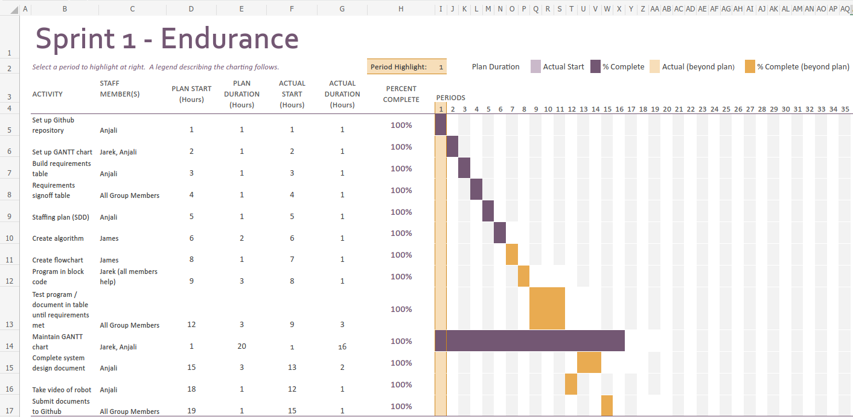

Link to excel: <https://live365monmouth-my.sharepoint.com/:x:/g/personal/s1328134_monmouth_edu/EdDvV-h0wiREukZ0GCLUdoUBx4zvVEF03gNoSXaqAqMoVQ?e=n369iH>

## Staffing Plan

| Name | Role | Responsibility | Reports To |
| --- | --- | --- | --- |
| Anjali | Manager | System Design Document, maintain GitHub, robot testing | N/A |
| James | Data / Planning | algorithm, flowchart, robot testing | Anjali (for SDD) |
| Jarek | Programmer | Gantt chart, block code, robot testing | Anjali (for SDD) |